

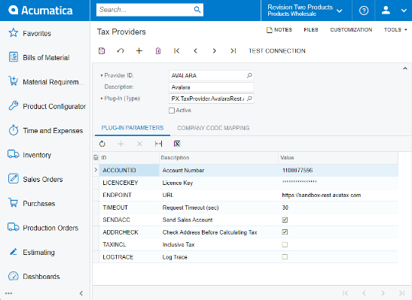

Acumatica + Avalara

Avalara is fully integrated with Acumatica and helps businesses of all sizes achieve compliance with transactional taxes, including sales and use, VAT, excise, communications, and other tax types. Acumatica sends transaction data to AvaTax, and AvaTax sends back the tax total.

* **Customers, salespeople, and others can see the tax owed in real-time**
* **Real-time tax rate calculations for 13,000+ U.S. taxing jurisdictions**
* **Monitors filing deadlines and automates returns and remittance**
* **Avalara automatically considers hundreds of thousands of taxability laws and jurisdictional boundaries**

Master Tax Compliance Inside Your ERP

For most businesses, sales tax is an obligatory, complex nightmare. Automating this process saves time, money, and effort. Avalara, working inside of Acumatica Sales Order Management and Retail Edition, dynamically delivers instantaneous sales tax decisions based on precise geo-location in more than 10,000 taxing jurisdictions. The system automatically considers hundreds of thousands of taxability rules and the latest jurisdiction boundaries to deliver the right rate and tax calculation.

**BENEFITS**

* Unified User Experience
* Integrated tax management, financial, and sales order processes.
* Familiar interface for order entry staff, nothing new for them to learn.
* Seamless Integration
* Built into the Acumatica platform.
* Simply turn it on.
* Minimize Calculation Errors and Data Entry
* Validate dates on financial forms, processes, and projects, rejecting those that do not match a financial period in the master calendar. Our cloud platform enables your connected business.
* Automatically calculate sales tax rates for thousands of jurisdictions.

Acumatica is the fastest-growing cloud and mobile ERP solution for mid-size companies, offering a wide range of adaptable, integrated solutions for your business. Configure, collect, manage, and report tax with Acumatica and integrated Avalara AvaTax. Acumatica Tax Management is integrated with other financial modules to centralize tax information and generate required tax filing reports.

Key business benefits

* Integrate tax automation with ERP financial and sales management.
* Instantly deliver the right tax rate and calculation for transactions.
* Automatically factor in tax laws and boundaries.
* Configure taxes the way you want to support sales, use, withholding, VAT, and reverse VAT taxes.
* Integrate with Acumatica financial modules that require tax calculation.

Related resources

* 9 Ways Integrations Fuel Digital Transformation [> LEARN MORE](https://www.acumatica.com/support-digital-transformation-with-acumaticas-rapid/)
* Why Growing Businesses Need ERP Software [> LEARN MORE](https://www.acumatica.com/drive-growth-with-an-erp-for-business-solution/)
* Schedule a Personalized Demo [> LEARN MORE](https://www.acumatica.com/request-a-demo/?r=50337)

“Avalara’s sales tax integration has been really beneficial for us. We do business in 45 states, and we can now add additional state information quickly. That has been extremely helpful. I would have had to hire a full-time person just to handle the different sales tax scenarios, and now it’s done in the background seamlessly.”

**–Andy Gale, CFO and COO, LiveView Technologies**

[> CUSTOMER STORIES](https://www.acumatica.com/success-stories/)

Flexible Tax Reporting

Configure tax reporting requirements for each tax. Generate summary reports and retrieve tax details for each tax zone. Prepare the statistical information required by tax authorities for filing tax reports.

Sales Tax Rate Calculation

Automatically calculate sales tax rates by integrating Acumatica and Avalara AvaTax. Dynamically deliver instantaneous sales tax decisions based on precise geo-location in 11,000+ taxing jurisdictions. The systems automatically consider hundreds of thousands of taxability rules and the latest jurisdictional boundaries to deliver the right rate and tax calculation. The returns filing process monitors deadlines with automated returns and remittances. Customers can simply turn on this feature to start calculating taxes and reduce long-term costs.

Audit Trail

Maintain a complete audit trail of all tax-related transactions. The system maintains the details of all tax-related documents, including the originating module, reference numbers, and date of the record. Adjustments can only be made through auditable transactions.

Streamlined Tax Zone Reporting

Automatically assign tax zones to new sales orders and invoices based on the country, state, and zip code.

Direct Tax Adjustments

Review tax reports and enter corrections directly in your tax accounting software. Corrections update the specified tax liability account in the General Ledger as well as the statistical tax information.

Tax Transactions Drill Down

Maintain a complete record of each tax transaction, including the originating module and transaction, the taxable amount, tax, reference number, and document type. Reconcile calculated tax with general ledger postings and drill down to the original transactions.